BLOCK 1



#
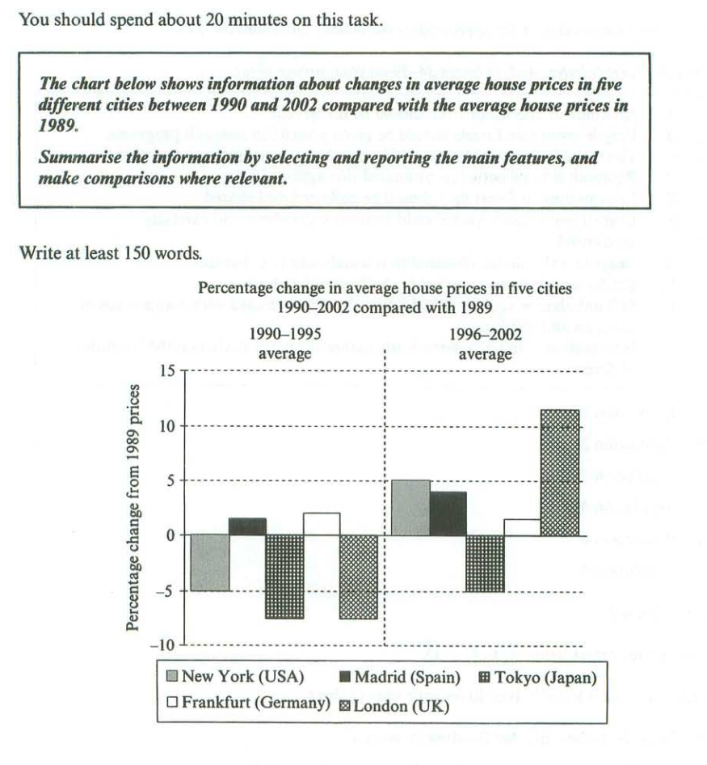

#
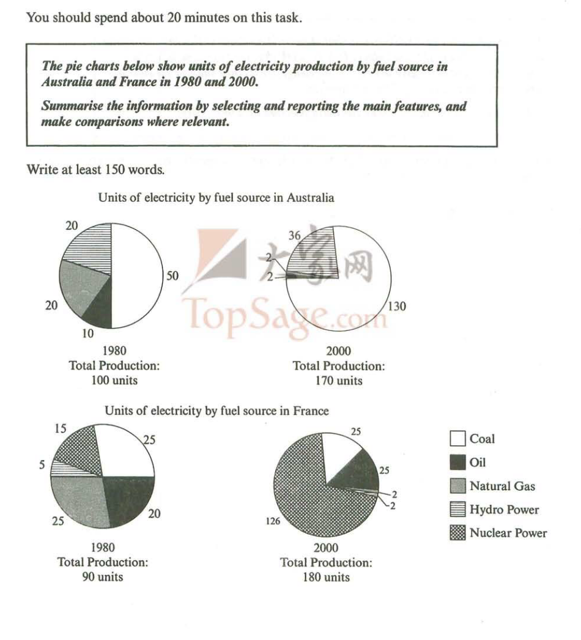

#

#
You should spend about 20 minutes on this task.
Write an introduction and the first body paragraph about the following topic:
● It is generally believed that some people are born with certain talents, for instance for sport or music, and others are not. However, it is sometimes claimed that any child can be taught to become a good sports person or musician.

Discuss both these views and give your own opinion.
Write at least 150 words.
#
You should spend about 20 minutes on this task.
Write an introduction and the first body paragraph about the following topic:
As most people spend a major part of their adult life at work, job satisfaction is an important element of individual wellbeing.

What factors contribute to job satisfaction?

How realistic is the expectation of job satisfaction for all workers?
Write at least 150 words.
#
You should spend about 20 minutes on this task.
Write explanatory note to the performance of the dissertation according to following plan.
1. General characteristics of the work
2. The urgency of the problem
3. The object of study
4. Subject of the study
5. Aim of the work
6. Method of research
7. Stages
Write at least 150 words
#
You should spend about 20 minutes on this task.
Write statement of purpose/motivation letter.
Write at least 150 words.

BLOCK 2

Describe an important choice you had to make in your life.

You should say:

• When you had this choice
• What you had to choose between
• Whether you made a good choice
• And explain how you felt when you were making this choice
#
Describe a job you have done.

You should say:

• How you got the job
• What the job involved
• How long the job lasted
• Describe how well you did the job
#
Describe a newspaper or magazine you enjoy reading.

You should say:

• What kind of newspaper / magazine it is
• Which parts of it you read regularly
• When and where you read it
• Explain why you enjoy reading it

#
Describe a small and successful company you know.

You should say:

• the name of the company
• how you learnt about it
• what kind of business this company does
• explain why you think this company is successful.
#
Speak about businesses.

You should say:

• Is market research important for export business?
• In business, do companies need to be competitive?
• Should companies promote competition and why?
• What should be the government’s role in how businesses are run?
• How can businesses benefit the community in which they are located?
• What kind of businesses are most popular?

#
Speak about government regulations.

You should say:

• Do most people in your country work for small or large businesses?
• What kind of businesses need the most help?
• Should the government help businesses or leave them alone?
• How important is regulation of businesses?
• What rights do large companies have?
• What do you think can be considered as emerging industries?
#
Speak about the Internet.

You should say:

• How often do most people use the internet?
• Do you think many people waste their time online?
• Are there drawbacks to its overuse?
• What kind of information can people find online?
• How has this changed the way that people get their information?
• What impacts does the internet have on students?
• How will the internet change society in the future?

#
Speak about Websites.

You should say:

• What Internet sites do people in your country use for entertainment?
• Why is more and more news now published on social media websites?
• What can we do to stop the spread of unreliable news?
• How have websites changed in the last decade?
• Should there be tighter regulation on websites?

BLOCK 3

Presentation by speciality “Innovations in the Sphere of Professional Activity”

